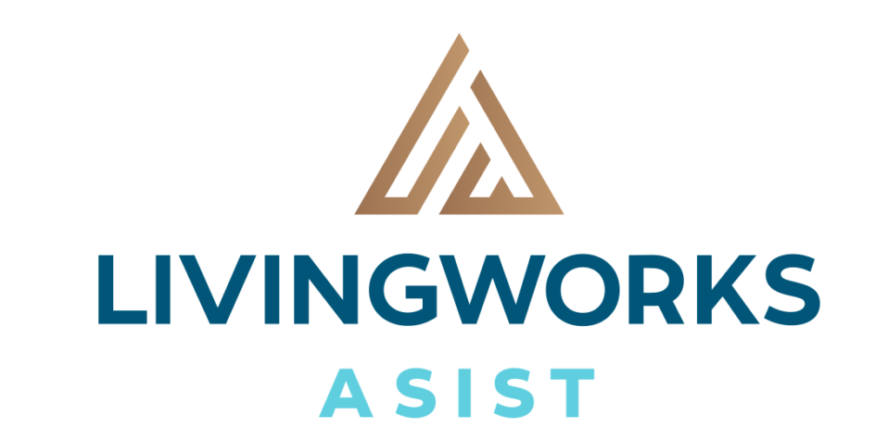  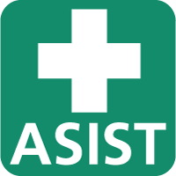  Workshop  The ASIST workshop is for professionals and/or caregivers who want to feel more comfortable, confident and competent in helping to prevent the immediate risk of suicide. Participation in the full two days is required in order to receive certification.  ASIST is designed to help participants recognize risk and learn how to intervene to keep a person at risk safe for now. Suicide can be prevented with the help of prepared professionals and/or caregivers. Enjoy small group discussions and skills practice that are based upon adult learning principles. Feel challenged and safe and learn suicide first aid.  New Training Dates  DATE: December, 5, 6, 2024  TIME: 9:00a.m. -5:00p.m.  LOCATION: King St. Community Church 611 King St. W., Oshawa, ONT.  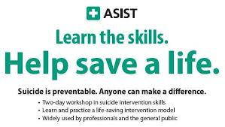 | ASIST:  APPLIED SUICIDE INTERVENTION SKILLS TRAINING CERTIFICATE  ────  Fees:  $275.00 per person. $250.00 Student rate or volunteers - (18 + yrs. old )  Payment:  Cheque, e-transfer, EFT or Credit Card  ────  Pre-registration is required.  No refunds, but registrations can be transferable  ────  Register early to reserve your place. Maximum of 30 registrants  Lucia Lee  Consulting  ASIST /safeTALK Trainer  Phone: 905-435-7638  Email: luciamlee@gmail.com

