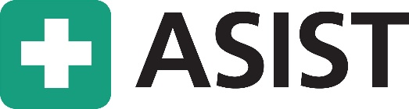
Learn the skills.
Help save a life.

Suicide is preventable. Anyone can make a difference.
- Two-day workshop in suicide intervention skills
- Learn and practice a life-saving intervention model
- Widely used by professionals and the general public
Date: 10/17/2024 & 10/18/2024 Time: 9:00AM – 5:00PM
Location: Geauga County Public Library Administrative Center
12701 Ravenwood Ave
Chardon, OH 44024
Hosted by: Ravenwood Health
Cost (General Public): $350 per person
Cost (Community Partners): $250 per person
12 CEUs
To inquire or register call Christina Charlillo at 440-823-3816 or email at charlilloc@ravenwoodhealth.org
ASIST works. Learn more and see the evidence at www.livingworks.net/asist

