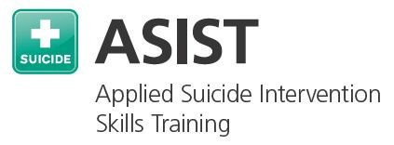**May 10th and 11th**

|  |
| --- |
|  |
|  |
| **ASIST is a two-day intensive interactive and practice-dominated course designed to teach suicide**  **first-aid to help a person at risk stay**  **safe and seek further help as needed.**  **This training is suitable for mental health and medical professionals, teachers, youth workers, police and correctional staff, clergy, and community volunteers.**  **“The model is easy to follow and provides caregivers practical steps to use in an intervention!**  **-ASIST Past Participant**  **This program has been approved for 13 Social Work Continuing Education hours for**  **relicensure, in accordance with 258 CMR. NASW-MA Chapter CE Approving Program, Authorization Number D91367.**  **Flat fee of $75.00 for CEU’s must attend BOTH days** |
|  |

**Calvary Baptist Church**

**429 Monponsett St.**

**Hanson, MA**

9:00am-5:00pm

Registration begins at 8:30am

**Cost $150 per person\***

**\*Actual cost of class is $300 per person, subsidized by our sponsors.**

***Scholarships available please inquire***

**Light lunch and snacks included**

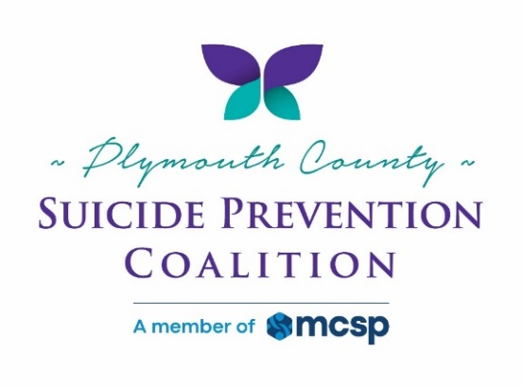

Must attend BOTH Dates

For enrollment email: jbabcock13@comcast.net or call 508-254-9320 for information

Must register by:

May 4, 2024

Space is Limited!

SPONSORS:

