DAV, Frank L. Bradford Chapter 18 and Vets4Vets Foundation: Trauma & Suicide Intervention Workshop February 8-10 2023.
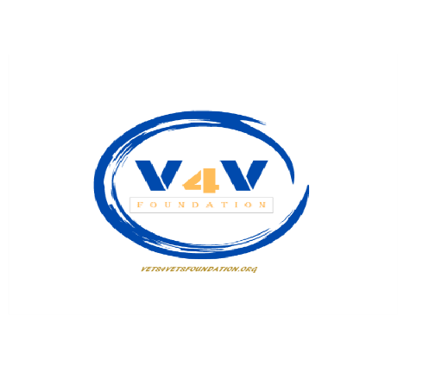

INFORMATION SHEET: Trauma and Suicide Intervention Workshop 8:30 am. – 4:30 pm.
Wednesday February 8, 2023 – Friday February 10, 2023
Guntersville Parks and Recreation Building 1500 Sunset Dr. Guntersville, AL.
Wednesday: North Classroom, Collective Group Thursday & Friday East & South Classrooms
LUNCH & REFRESHMENTS ARE PROVIDED EACH DAY
TRAUMA: 6 CEUs SUICIDE INTERVENTION: 12 CEUs
PTSD * Certified ASIST Model
Developmental Identifying/Connecting/Preventing
Relationship Small Group Interaction
Intergenerational Role Play
Neurological Underpinnings Evaluating Support Response
Suicide Antecedents Follow-up
*Must attend the full 16-hour instruction for certification.
Starting Thursday, it is a closed-group format. No observers are permitted past the scheduled participants.
Each scheduled participant costs approximately $500 to attend this workshop, even if they are no-shows. The hosting parties have to prepay LivingWorks Edu. Inc. for printed materials, and prepay certified instructors and their per diem, food and refreshments, and venue costs. We encourage at least (1) One alternate per (2) Two participants.

Vets4VetsFoundation@yahoo.com (256) 599-0291

