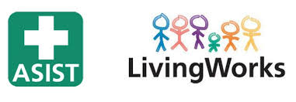  fe  The ASIST workshop is for professionals and/or caregivers who want to feel more comfortable, confident and competent in helping to prevent the immediate risk of suicide. Participation in the full two days is required in order to receive certification.  ASIST is designed to help participants recognize risk and learn how to intervene to keep a person at risk safe for now. Suicide can be prevented with the help of prepared professionals and/or caregivers. Enjoy small group discussions and skills practice that are based upon adult learning principles. Feel challenged and safe and learn suicide first aid.  New Training Dates  DATE: Sunday-Monday, May 15-16, 2022  TIME: 9:00a.m. -5:00p.m.  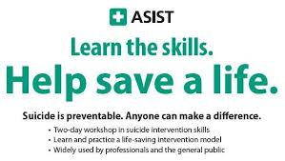  LOCATION: Springfield Golf and Country Club 2054 Gordon St, Guelph, ON  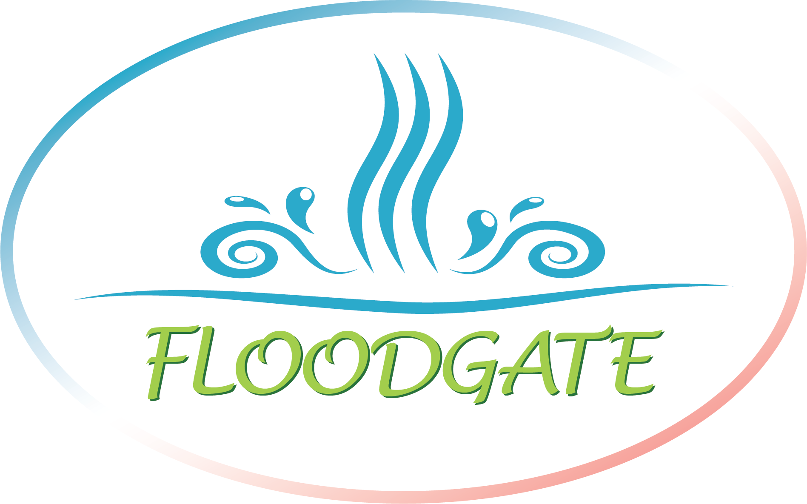 Brought to you by Floodgate Coaching, Counselling, and Consulting | ASIST:  APPLIED SUICIDE INTERVENTION SKILLS TRAINING CERTIFICATE  ────  Fees:  $295.00 per person, includes workshop materials, breakfast, lunch and snacks, and parking.  Payment:  E-transfer or Paypal  ────  Pre-registration is required.  No refunds, but registrations can be transferable  ────  Register early to reserve your place. Space is limited.  Becky Hills  ASIST Trainer  Phone: 226-789-9965  Email: becky@floodgatecoaching.ca

