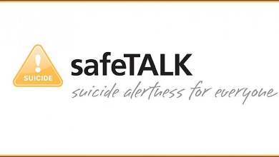

COURSE REGISTRATION & PARTICIPANT INFORMATION
NAME:
EMAIL:
PHONE: ALTERNATE PHONE:
DIETARY RESTRICTIONS/ALLERGIES:
SPECIAL NEEDS: ( i.e. auditory or visual impairment, mobility)
PLEASE CHECK PREFERRED DATE OF TRAINING:
June 29th, 2021 9 a.m. – 12 p.m. July 28th, 2021 9 a.m. – 12 p.m.
Whitby location: Durham Corporate Centre, 105 Consumers Drive, L1N 1C4

Detailed information for each training will be sent following registration.
Further information and COURSE description available at www.mlicounsellingservices.com
and at www.livingworks.net

Course Fee: $ 45.00 – includes participant manual and certificate upon completion of course
(Discounted Student and Not-for-Profit rates can be arranged with Course Instructor)
Payment: due at registration in order to secure spot
- CHEQUES: payable to MLI COUNSELLING SERVICES INC, 22 Inglenook Ct Whitby L1R1H2
- E-TRANSFER: please submit via mlicounselling@gmail.com
- PayPal option available at www.mlicounsellingservices.com
CANCELLATION POLICY: If the Instructor is forced to cancel the course, a FULL REFUND will be provided. If a PARTICIPANT withdraws within one week of the course start date, a $15.00 fee will be deducted from the course fee prior to being returned.
TO COMPLETE REGISTRATION, SUBMIT FORM TO mlicounselling@gmail.com.

MLI COUNSELLING SERVICES

