**Make a connection. Help save a life.**

**Suicide alertness for everybody.**

• Half day (3.5hrs) training in suicide alertness skills

• Apply the *TALK* steps (Tell, Ask, Listen, and Keep Safe) to connect a person with thoughts of suicide to a suicide first-aid intervention caregiver.

• Powerful videos illustrate the importance of suicide alertness, while discussion and practice stimulate learning.

**Who Should Attend?**

Anyone 15 or over who wants to help people be safer from suicide.

**Date: 6th March 2021  
Time: 9:00am – 12:30pm**

**Venue: Upper Murray Events Centre  
Cost: Free - includes morning tea**

**Register by pointing your phone camera**

**at the QR code and follow the prompts.**

**Or email your name and contact details to**

**chris@chrispidd.com.au**



Chris Pidd- Facilitator

[chris@chrispidd.com.au](mailto:chris@chrispidd.com.au)

0477 888 807

LivingWorks Trainer ID: 35452



**Community Inclusion Project**

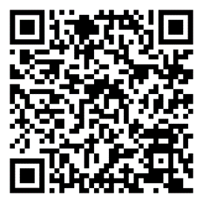

**Proudly Sponsored By**



**Community Inclusion Project**