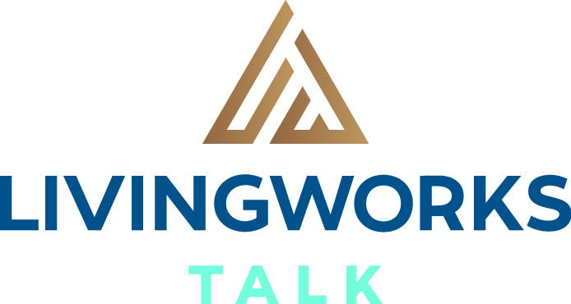

Make a connection. Help save a life.

Suicide is preventable. Anyone can make a difference.

- Half-day (3.5hrs) training in suicide alertness skills
- Learn four basic steps to create a life-saving connection
- Widely used by professionals and the general public

Date: 27th February

Venue: Upper Murray Events Centre

Time: 9:00am – 12:30pm

Cost: Free

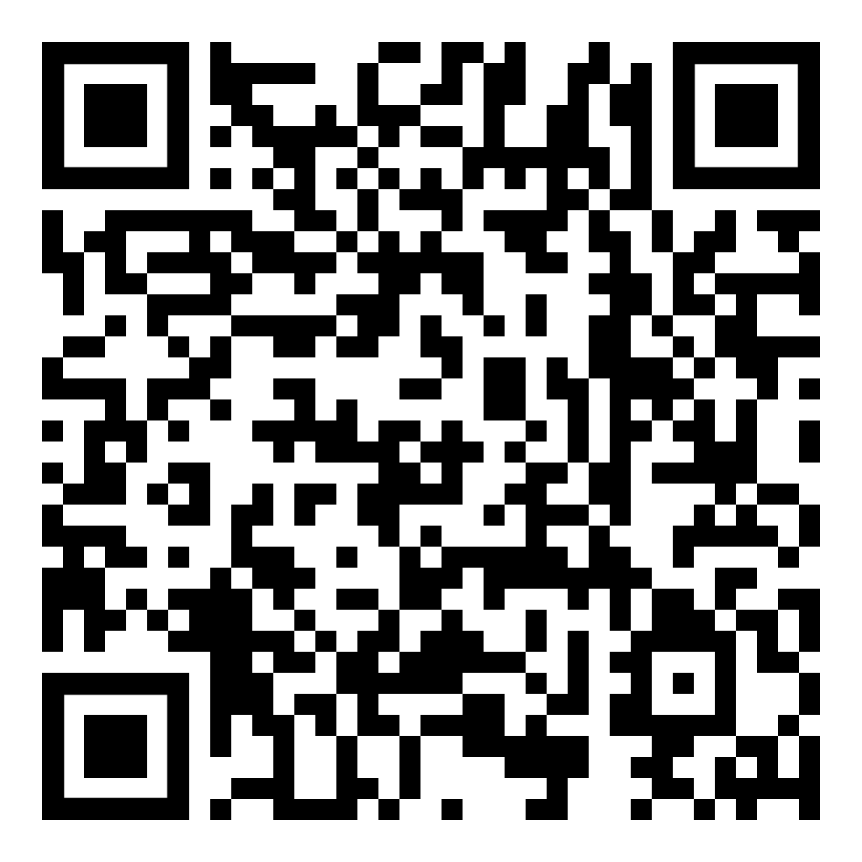
Register by pointing your phone camera at the QR code and follow the prompts.

Or email your name and contact details to: chris@chrispidd.com.au

