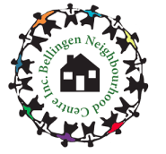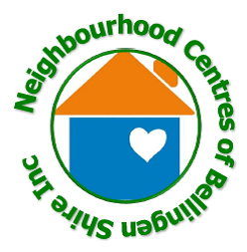

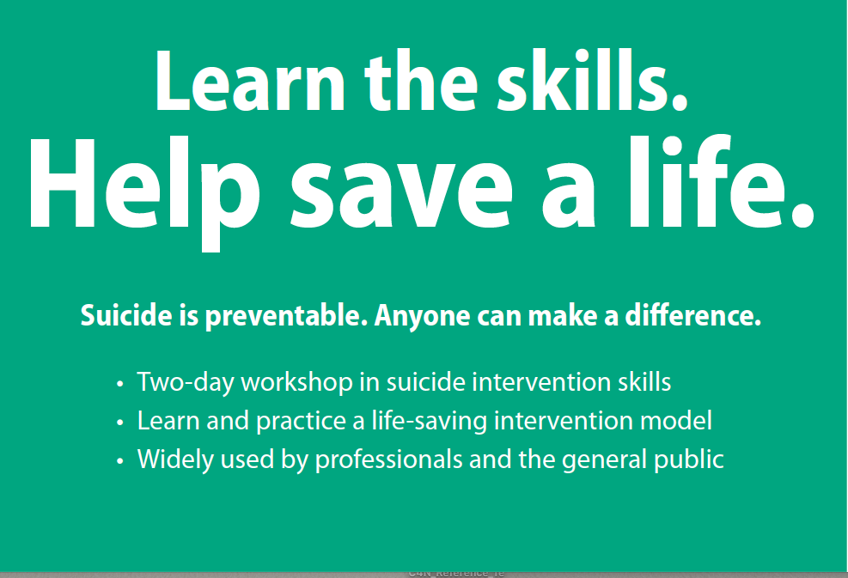
https://www.livingworks.net/asist

Join a local ASIST (Applied Suicide Intervention Skills) workshops:

Bellingen - Thursday 5th and Friday 6th November 9am – 5pm
Cedar Bar & Kitchen, 8 Church Street, Bellingen

Dorrigo - Saturday 14th & Sunday 15th November 9am – 5pm
Dorrigo Mountain Resort, Waterfall Way, Dorrigo

Cost: $30 non-refundable registration fee. Those who attend the two days will receive a $30 voucher to spend in their local community.

For Information or to Register: Cate Clark – 0428411906 clark.cate@gmail.com

"This activity is funded by Healthy North Coast through the North Coast PHN program."

