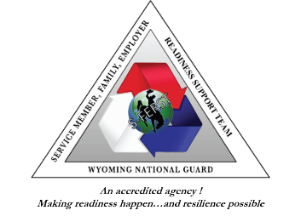
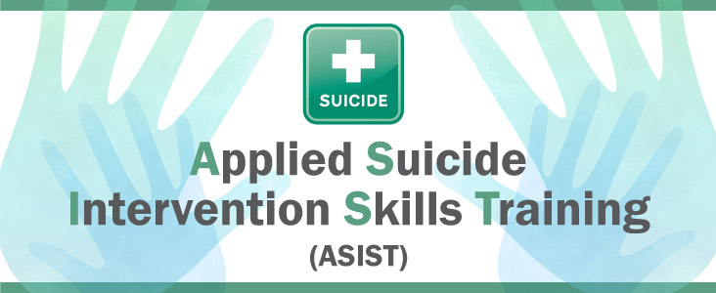

Save the Date and Register
July 8th and 9th, 2020
Wyoming Army National Guard Regional Training Institute
Guernsey, WY 82214
About This Training
Applied Suicide Intervention Skills Training ASIST is a two-day, two-trainer, workshop designed for members of all caregiving groups. Family, friends, and other community members may be the first to talk with a person at risk, but have little or no training. ASIST can also provide those who are in formal helping roles with professional development to ensure that they are prepared to provide suicide first aid help as part of the care they provide.
The emphasis is on teaching suicide first-aid to help a person at risk stay safe and seek further help as needed. Participants learn to use a suicide intervention model to identify persons with thoughts of suicide, seek a shared understanding of reasons for dying and living, develop a safeplan based upon a review of risk, be prepared to do follow-up, and become involved in suicide-safer community networks. The learning process is based on adult learning principles and highly participatory. Graduated skills development occurs through mini-lectures, facilitated discussions, group simulations, and role plays. (MUST attend full 2 day training; no exceptions due to the content of the training.)

Program Objectives:
After training, ASIST participants should be able to:
- Recognize that caregivers and persons at risk are affected by personal and societal attitudes about suicide.
- Discuss suicide in a direct manner with someone at risk.
- Identify risk alerts and develop related safeplans.
- Demonstrate the skills required to intervene with a person at risk of suicide.

- List the types of resources available to a person at risk, including themselves.
- Make a commitment to improving community resources.
- Recognize that suicide prevention is broader
than suicide first-aid and includes life promotion and self-care for caregivers.

Information regarding parking, building location and room numbers will be updated within the next several days.
AGENDA BOTH DAYS

- 8:00 am Registration and light breakfast
- 8:30 am Training
- 12:30 pm Lunch
- 1:30 pm Training
- 5:00 pm Training ends
Breaks will be given at a time to be determined by the trainers.

CERTIFICATES: Evaluations, sign out and certificates will be awarded at 4:15 pm on Day 2
Attendees spending excessive amount of time outside the training or engaging in activities that may not be associated with the training may not receive credit. No partial credit will be given. Must be at training 2 full days; no exceptions due to the content of the training.
We look forward to spending time with you all and appreciate your willingness to help your communities by taking the ASIST Training.

If you have any special accommodations, questions, or would like to register, please contact:
Jeremy Bay – Email jeremy.d.bay.ctr@mail.mil
Grace for 2 Brothers – admin@gracefor2brothers.com

Training and materials are provided to the community through a grant from Cheyenne Regional Medical Center to Grace for 2 Brothers. Training and materials are provided to the military community by the Wyoming Army National Guard Suicide Prevention Program and the Service Member, Family, Employer, Readiness Support Team.
