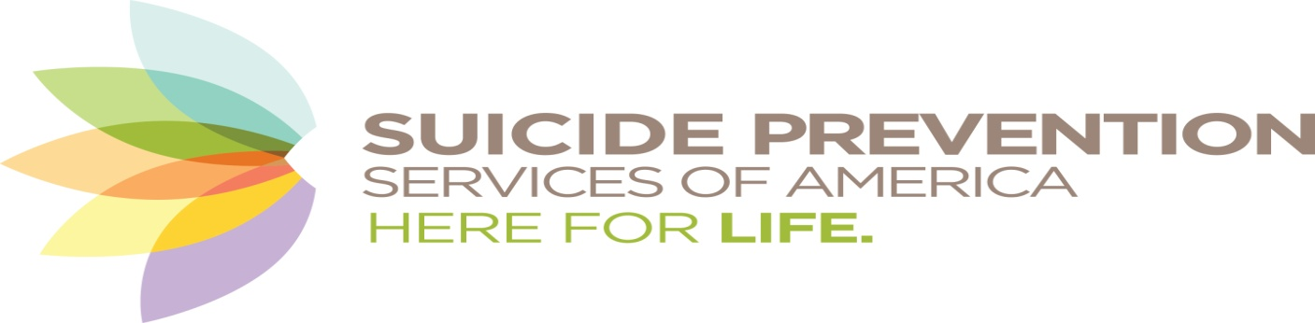
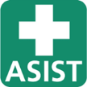 Applied Suicide Intervention Skills Training

ASIST is open to anyone 16 years and older interested in learning how to help when someone may be at immediate risk for suicide. It is an interactive group format designed to build practical skills through information, discussion, and role-play. ASIST is internationally recognized.

Fee: $80 - ADVANCE REGISTRATION IS REQUIRED:
www.spsamerica.org/prevention-training
Questions? Natasha 630-482-9699 or natasha@spsamerica.org
- Friday July 24 AND Saturday July 25 2020 8:30 am sharp – 4:30 pm
- Amita Health/Mercy Medical Center 1325 North Highland Avenue Aurora IL
- Lunch is provided – the group eats together on site
- Both days must be attended in full to obtain lifetime-valid certification

Most people considering suicide share their distress and their intent with others. Appropriate training can help us see and respond to these invitations for help. ASIST helps participants understand the ways personal and societal
attitudes affect asking for help and interventions.

ASIST workshops utilize the principles of adult learning, building on contributions of all participants. Please come with an expectation to share and engage!
The mission of Suicide Prevention Services is to open minds, save lives, and restore hope through prevention, intervention, and postvention, using education, advocacy and collaboration.

